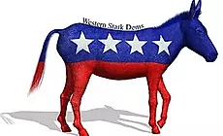

WESTERN STARK COUNTY DEMOCRATIC CLUB

The Western Stark County Democratic club was formed over 50 years ago. The Club’s most important purpose is to be of benefit to the Democratic Party and Democratic candidates.

Meetings are held on Tuesday evenings, 6 times a year (see dates below), at the Massillon Eagles #190, located at 303 Weirich Boulevard NW in Massillon, at 7:00 p.m.

The officers are as follows for the year 2020:

Administrator: John Kurtzman 330-575-4519
Secretary: Jeanette Mullane 330-323-0965
Deputy Treasurer: Glenn Gamber 330-837-0389

Membership dues are $25.00 per year. If you are interested in becoming a member, contact Jeanette Mullane at 330-323-0965 or just attend one of the meetings.

The meetings for this year are:
January 28th
February 25th
March 24th
September 15th
October 20th
November 17th

Annual Steak Fry: To be held in June. Details to be announced.

Clambake & Steak Fry: To be held in the Fall. Details to be announced

